Statistics 601 – Assignment 1 — Due September 20

Name: Naiqing Cai email:ncai5@wisc.edu

1. 1）graphical methods: Q–Q plot

**Definition**

It is a plot for comparing two probability distributions by plotting their quantiles against each other.

**Advantages**

It can not only test whether the sample is to specify the distribution, also can detect whether the two samples have the same distribution.

**Example (Two classes exam performance data)**

Many '+' number deviate from the reference line, so it can be considered that two class grades don't follow the same distribution.



Figure 1.1 Q–Q plot of exam performances

1. 2）numerical methods: Coefficient of Variation

**Definition**

It is defined as the ratio of the standard deviation to the mean. It is a standardized measure of dispersion of a distribution.

**Advantages**

The standard deviation of data must always be understood in the context of the mean of the data. In contrast, the actual value of the CV is independent of the unit in which the measurement has been taken, so it is a dimensionless number.

**Disadvantages**

When the mean value is close to zero, the coefficient of variation will approach infinity and is therefore sensitive to small changes in the mean.

Unlike the standard deviation, it cannot be used directly to construct confidence intervals for the mean.

**Example (weather in Madison in winter)**

Celsius: [-10, 2, -8, 5, 7, -15] Fahrenheit: [13, 15, 6, 14, 1, 10]

The sample standard deviations are 9.02 and 5.42, respectively.

The CV of the first set is 9.02/-3.17 = -2.85. For the second set (which are the same temperatures) it is 5.42/9.83 = 0.55

2.(a) (b) (c)

The histograms of sample mean and sample variance from the 100 samples when n=10, n=40, n=160 are as followed.

Rplot01.pdfRplot02.pdf

Figure 2.1 sample mean Figure 2.2 sample variance

2.(d)

From the histograms in (a)–(c), l found that with the increase of n, which is the number of observations each time, the distribution of sample mean and sample variance are more likely to be concentrated, which means the range and the distribution becomes narrower. Specifically, when n=10, the data is close to normal and with out outliers. When n=40, mild skewness is acceptable but not outliers. When n=160, it will have strong skewness.

2.(e)

2(e)mean.pdf2(e)var.pdf

Figure 2.3 sample mean Figure 2.4 sample variance

From the histograms, it also shows that with the increase of n, the distribution of sample mean and sample variance are more likely to be concentrated, that is the range of both are smaller and the distribution is much narrower.

2.(f)







Compared with my simulations, I find that when n tend to be infinite, the mean of sample mean will be a constant and the variance of sample mean will also be a constant. Also the expectation of sample variance will tend to be the variance the population.

is the variance of sample mean, and  is the variance of samples of the population.

2.(g)









is the variance of sample mean, and is the variance of samples of the population.

3.(a)

Hypothesis:



Parameters:

: where 109-11.png is the mean of the population posttest scores minus the mean of the population pretest scores.

: equals to 0

3.(b)

3(b)outlier.pdf3(b)skewness.pdf

Figure 3.1 outliers Figure 3.2 skewness

3.(c) T-test (one sided test with 95% confidence interval)

**step 1: hypothesis**



**step 2: test statistics**



the standard error is 

sample mean: 



**step 3: find the p-value**

 is 0.0286, less than 0.05, so at the 5% level, we should reject the  . Thus, there is strong evidence that the mean scores of Posttest is greater than that of Pretest. In this way, the training improves listening skills.

3.(d) 90% confidence interval







90% confidence interval for the mean increase in listening score due to the intensive training is [0.212, 2.689], which means there are 90% probability that the mean increase in listening score due to the intensive training is in [0.212, 2.689]

4.(a)boxplot and numerical statistics to summarize the data

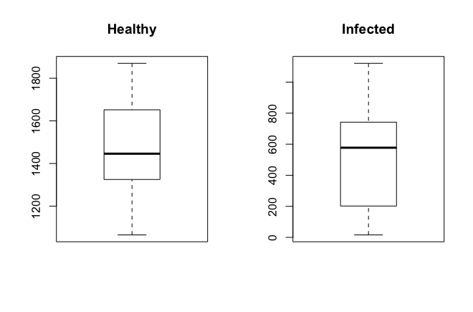

Figure 4.1 boxplot of healthy and infected buds

|  |  |  |
| --- | --- | --- |
|  | Healthy | Infected |
| median | 1446 | 577.5 |
| mean | 1480 | 549.4286 |
| standard deviation | 248.9849 | 343.4586 |

Table 4.2 numerical statistics of healthy and infected buds

**Conclusions:** The virus makes the stem volume of infected 2-year-old seedlings much less than the healthy one and makes the standard deviation of infected one much larger than the healthy one, which means the differences between samples from infected ones are larger.

4.(b) T-test (one sided test with 95% confidence interval, var.equal=TRUE)

**step 1: hypothesis**



Parameter:

: is mean stem volume of 2-year-old seedlings propagated from virus-infected buds

: is the mean stem volume of 2-year-old seedlings propagated from   healthy buds

**step 2: test statistics**





**step 3: find the p-value**

, which is less than 0.05, so we should reject the . Thus, there is evidence that the mean stem volume of 2-year-old seedlings propagated from virus-infected buds is smaller than those propagated from healthy buds.

4.(c) 95% confidence interval (two-sided, var.equal=TRUE)





95% confidence interval for the difference of the mean stem volume of 2-year-old seedlings between the two groups is [654.3586,1206.7842], which means there are 95% probability that difference of the mean stem volume of 2-year-old seedlings between the two groups is in [654.3586,1206.7842]

4.(d) T-test (two-sided test with 95% confidence interval, var.equal=TRUE)

**step 1: hypothesis**



Parameters:

: is the mean stem volume of 2-year-old seedlings propagated from virus-infected buds

: is the mean stem volume of 2-year-old seedlings propagated from   healthy buds

**step 2: test statistics**





**step 3: find the p-value**

, which is less than 0.05, so we should reject the . Thus, there is evidence that the mean stem volume of 2-year-old seedlings propagated from virus-infected buds is different from those propagated from healthy buds.

4.(e)

**Assumptions：**

1）two samples are paired

2）, ,

3) , are unknown

**Assess the assumptions:**

1)Histogram: From the histogram plot, we can know that two samples are not paired. So the assumption of two samples are paired is not reasonable.



Figure 4.3 Histogram of buds

2)Q-Q Plot: From the plots, we can easily conclude that the random samples of both buds are from the normal population distribution. So the assumption is reasonable.

../qqplot1.pdf../qqplot2.pdf

Figure 4.4 Q-Q Plot of buds

3)Levene’s test: According to the test, we can found that p=0.1112>0.05, so the variance of both population is the same. So the assumption  is reasonable.

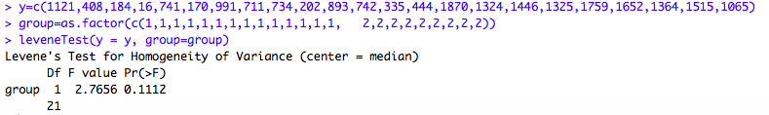

Figure 4.5 Levene’s test of buds

**Remedial measures:**

To make the two samples paired, we can choose two kinds of buds from several different locations, each location we randomly choose one healthy bud sample and one infected bud sample.

4.(f) Welch’s T test (two-sided 95% confidence interval, var.equal=FALSE)

Assumptions：Random Samples are not variance equal.

**step 1: hypothesis**



Parameters:

: is the mean stem volume of 2-year-old seedlings propagated from virus-infected buds

: is the mean stem volume of 2-year-old seedlings propagated from   healthy buds

**step 2: test statistics**





**step 3: find the p-value**

, which is less than 0.05, so we should reject the . Thus, there is evidence that the mean stem volume of 2-year-old seedlings propagated from virus-infected buds is different from those propagated from healthy buds.

**step 4: confidence interval (two sided)**

95% confidence interval for the difference of the mean stem volume of 2-year-old seedlings between the two groups is [672.9032,1188.2396], which means that there are 95% probability the difference of the mean stem volume of 2-year-old seedlings between the two groups is in [672.9032,1188.2396]

4.(g) randomization test

Rplot.pdf

Figure 4.6 randomization test

4.(h) nonparametric test

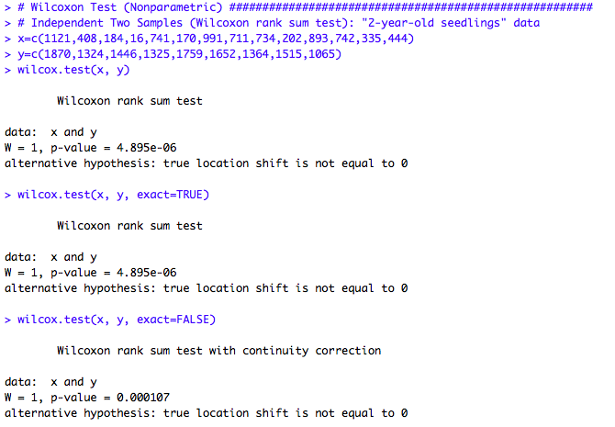

Figure 4.7 nonparametric test

4.(i) Compare the results

4.(j)

5.(a)scatterplot numerical statistics to summarize the data

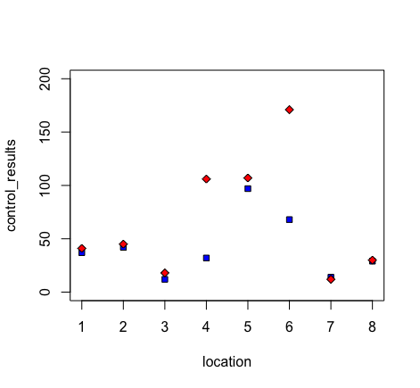

Figure 5.1 scatterplot of biological control and chemical control

|  |  |  |
| --- | --- | --- |
|  | Biological control | Chemical control |
| median | 34.5 | 43 |
| mean | 41.375 | 66.25 |
| standard deviation | 28.47524 | 55.91767 |

Table 5.2 numerical statistics of biological control and chemical control

**Conclusions:** The mean of the chemical control is high than that of biological control, which means it can capture more moths on average. But the standard of the chemical control is also larger than biological control’s, which means it varies largely from plot to plot.

5.(b) T-test (one sample, two-sided test with 95% confidence interval)

**step 1: hypothesis**



Parameters:

: the mean of the difference of the two types of control

: equals to 0

**step 2: test statistics**



the standard error is 

sample mean: 



**step 3: find the p-value**

 is about 0.1234, so at the 5% level, we should accept the  . Thus, there is strong evidence that the means between the two types of control is no difference.

5.(c) confidence interval

95% confidence interval for the difference of the means between the two types of control is [-58.4661,8.7161], which means there are 95% probability that the difference of the means between two types of control is in [-58.4661,8.7161]

5.(d)

**Assumptions：**

1) two samples are paired

2) 

3) is unknown

**Assess the assumptions:**

1)Histogram: From the histogram plot, we can know that two samples are paired.



Figure 5.3 Histogram of two kinds of control

2)Q-Q Plot: From the plot, we can easily conclude that the difference of two kinds of control is not from the normal population distribution.

601/hw1/qqplot3.pdf

Figure 5.4 Q-Q Plot of difference of two kinds of control

**Remedial measures:**

To make the assumption that samples are from the normal population distribution reasonable, we should do transformation to the data and make them be the normal distribution.

5.(e) T-test (two samples, two-sided test with 95% confidence interval)

1）Transformation the data

To make the assumption that samples are from the normal population distribution reasonable, we should do transformation to the data. I transform them by log(data). To verify that they are from the normal population distribution, I do the QQ-plot of the transformed data.

qqplot%20trans1.pdfqqplot%20trans2.pdf

Figure 5.5 QQ-plot of the transformed data

It can be found from the figure that the transformed data are from normal distribution. Then we can do t-test for them.

2) T-test (two-sided test with 95% confidence interval)

**step 1: hypothesis**



Parameters:

: the mean of the difference of the two types of control

: equals to 0

**step 2: test statistics**





**step 3: find the p-value**

 is about 0.0888, so at the 5% level, we should accept the  . Thus, there is evidence that the means between the two types of control is no difference.

**step 4: confidence interval**



95% confidence interval for the difference of the means between the two types of control is [-0.7346,0.0659], which means there are 95% probability that the difference of the means between two types of control is in [-0.7346,0.0659]

5.(f) randomization test

5(f).pdf

Figure 5.6 randomization test

5.(g) nonparametric test

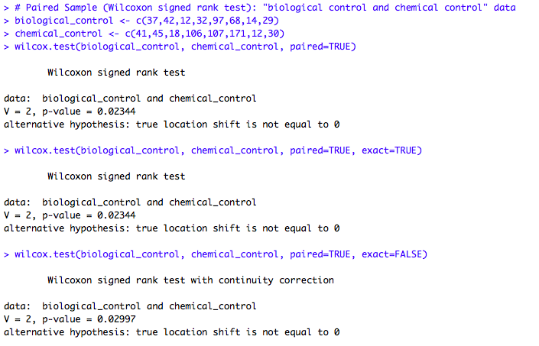

Figure 5.7 nonparametric test

5.(h) Compare the results

6. a cool product

(a) hypothesis testing

**step 1: hypothesis**

Assumptions：

1) two samples (the height of male and the height of female)are paired, it is reasonable because the data of the height of male and female are one-to-one correspondence in each country.

2），is unknown



Parameters:

: the mean of the difference between the height of male and female worldwide in 1996

: equals to 0

**step 2: test statistics**

**step 3: find the p-value**

**step 4: confidence interval**

(b) confidence interval

(c) central limit theorem

**Appendix**

|  |
| --- |
| 2(a)(b)(c)  # sample mean  S = 100  par(mfrow = c(1,3)) # plot 4 figures  for(n in c(10,40,160)){  sample_mean=rep(NA,S)  for(i in 1:S){  sample_norm=rnorm(n,2,2)  sample_mean[i]=mean(sample_norm)  }  if (n == 10){  hist(sample_mean, xlim=c(0,4), ylim=c(0,30),xlab="sample mean",  col=rgb(0,0,1,1/4), main="random sample(n=10) from N(2,4)",  breaks = seq(0,4,0.2))  }  if (n == 40){  hist(sample_mean, xlim=c(0,4), ylim=c(0,30),xlab="sample mean",  col=rgb(0,1,1,1/4), main="random sample(n=40) from N(2,4)",  breaks = seq(0,4,0.2))  }  if (n == 160){  hist(sample_mean, xlim=c(0,4), ylim=c(0,30),xlab="sample mean",  col=rgb(0,1/4,1,1/4), main="random sample(n=160) from N(2,4)",  breaks = seq(0,4,0.2))  }  }  # sample variance  S = 100  par(mfrow = c(1,3)) # plot 4 figures  for(n in c(10,40,160)){  sample_var=rep(NA,S)  for(i in 1:S){  sample_norm=rnorm(n,2,2)  sample_var[i]=var(sample_norm)  }  if (n == 10){  hist(sample_var, xlim=c(0,10), ylim=c(0,100),xlab="sample var",  col=rgb(0,0,1,1/4), main="random sample(n=10) from N(2,4)",  breaks = seq(0,10,0.5))  }  if (n == 40){  hist(sample_var, xlim=c(0,10), ylim=c(0,100),xlab="sample var",  col=rgb(0,1,1,1/4), main="random sample(n=40) from N(2,4)",  breaks = seq(0,10,0.5))  }  if (n == 160){  hist(sample_var, xlim=c(0,10), ylim=c(0,100),xlab="sample var",  col=rgb(0,1/4,1,1/4), main="random sample(n=160) from N(2,4)",  breaks = seq(0,10,0.5))  }  } |
| **2(e)**  # sample mean  S = 100  par(mfrow = c(1,3)) # plot 4 figures  for(n in c(10,40,160)){  sample_mean=rep(NA,S)  for(i in 1:S){  sample_norm=rbinom(n,10,0.2)  sample_mean[i]=mean(sample_norm)  }  if (n == 10){  hist(sample_mean, xlim=c(0,5), ylim=c(0,50),xlab="sample mean",  col=rgb(0,0,1,1/4), main="random sample(n=10) from B(10,0.2)",  breaks = seq(0,5,0.5))  }  if (n == 40){  hist(sample_mean, xlim=c(0,5), ylim=c(0,50),xlab="sample mean",  col=rgb(0,1,1,1/4), main="random sample(n=40) from B(10,0.2)",  breaks = seq(0,5,0.5))  }  if (n == 160){  hist(sample_mean, xlim=c(0,5), ylim=c(0,50),xlab="sample mean",  col=rgb(0,1/4,1,1/4), main="random sample(n=160) from B(10,0.2)",  breaks = seq(0,5,0.5))  }  }  # sample variance  S = 100  par(mfrow = c(1,3)) # plot 4 figures  for(n in c(10,40,160)){  sample_var=rep(NA,S)  for(i in 1:S){  sample_norm=rbinom(n,10,0.2)  sample_var[i]=var(sample_norm)  }  if (n == 10){  hist(sample_var, xlim=c(0,10), ylim=c(0,100),xlab="sample var",  col=rgb(0,0,1,1/4), main="random sample(n=10) from B(10,0.2)",  breaks = seq(0,10,0.5))  }  if (n == 40){  hist(sample_var, xlim=c(0,10), ylim=c(0,100),xlab="sample var",  col=rgb(0,1,1,1/4), main="random sample(n=40) from B(10,0.2)",  breaks = seq(0,10,0.5))  }  if (n == 160){  hist(sample_var, xlim=c(0,10), ylim=c(0,100),xlab="sample var",  col=rgb(0,1/4,1,1/4), main="random sample(n=160) from B(10,0.2)",  breaks = seq(0,10,0.5))  }  } |
| **3(b)(c)(d)**  # outlier  par(mfrow=c(1,2))  subject<-c(1,2,3,4,5,6,7,8,9,10,11,12,13,14,15,16,17,18,19,20)  Pretest<-c(30,28,31,26,20,30,34,15,28,20,30,29,31,29,34,20,26,25,31,29)  boxplot(Pretest,range = 1.5,main="outlier of Pretest")  Posttest<-c(29,30,32,30,16,25,31,18,33,25,32,28,34,32,32,27,28,29,32,32)  boxplot(Posttest,range = 1.5,main="outlier of Posttest")  # skewness  par(mfrow=c(1,2))  Pretest<-c(30,28,31,26,20,30,34,15,28,20,30,29,31,29,34,20,26,25,31,29)  hist(Pretest,main="skewness of Pretest")  Posttest<-c(29,30,32,30,16,25,31,18,33,25,32,28,34,32,32,27,28,29,32,32)  hist(Posttest,main="skewness of Posttest")  # t-test  out = t.test(x=c(-1,2,1,4,-4,-5,-3,3,5,5,2,-1,3,3,-2,7,2,4,1,3),alternative = "greater", mu = 0, conf.level = .95)  out$statistic  out$p.value  # confidence interval  out = t.test(x=c(-1,2,1,4,-4,-5,-3,3,5,5,2,-1,3,3,-2,7,2,4,1,3),alternative = "two.sided", mu = 0, conf.level = .90)  out$conf.int |
| **4(a)(b)(c)**  **#** summary plots  Healthy<-c(1870,1324,1446,1325,1759,1652,1364,1515,1065)  Infected<-c(1121,408,184,16,741,170,991,711,734,202,893,742,335,444)  median(Healthy)  mean(Healthy)  sd(Healthy)  median(Infected)  mean(Infected)  sd(Infected)  boxplot(Healthy,main='Healthy')  boxplot(Infected,main='Infected')  # t-test  x=c(1121,408,184,16,741,170,991,711,734,202,893,742,335,444)  y=c(1870,1324,1446,1325,1759,1652,1364,1515,1065)  out = t.test(x, y , alternative = "less", mu = 0, var.equal=TRUE, paired = FALSE, conf.level = .95)  out$statistic  out$p.value  # confidence interval  x=c(1121,408,184,16,741,170,991,711,734,202,893,742,335,444)  y=c(1870,1324,1446,1325,1759,1652,1364,1515,1065)  out = t.test(y, x, alternative = "two.sided", mu = 0, paired = FALSE, var.equal=TRUE, conf.level = .95)  out$conf.int |
| **4(d)**  # t-test  x=c(1121,408,184,16,741,170,991,711,734,202,893,742,335,444)  y=c(1870,1324,1446,1325,1759,1652,1364,1515,1065)  out = t.test(x, y , alternative = "two.sided", mu = 0, var.equal=TRUE,paired = FALSE,conf.level = .95)  out$statistic  out$p.value |
| **4(e)**  # qq-plot  x=c(1121,408,184,16,741,170,991,711,734,202,893,742,335,444)  qqnorm(x,main = "Q-Q Plot of infected buds")  qqline(x, col=2, lwd=2)  y=c(1870,1324,1446,1325,1759,1652,1364,1515,1065)  qqnorm(y,main = "Q-Q Plot of healthy buds")  qqline(y, col=2, lwd=2)  # Levene’s test  x=c(1121,408,184,16,741,170,991,711,734,202,893,742,335,444)  y=c(1870,1324,1446,1325,1759,1652,1364,1515,1065)  y=c(1121,408,184,16,741,170,991,711,734,202,893,742,335,444,1870,1324,1446,1325,1759,1652,1364,1515,1065)  group=as.factor(c(1,1,1,1,1,1,1,1,1,1,1,1,1,1, 2,2,2,2,2,2,2,2,2))  leveneTest(y = y, group=group) |
| **4(f)**  # Welch’s T test  x=c(1121,408,184,16,741,170,991,711,734,202,893,742,335,444)  y=c(1870,1324,1446,1325,1759,1652,1364,1515,1065)  out = t.test(y,x , alternative = "two.sided", mu = 0, paired = FALSE,conf.level = .95)  out$statistic  out$p.value  out$conf.int |
| **4(g)(h)**  # Randomization Test  x=c(1121,408,184,16,741,170,991,711,734,202,893,742,335,444)  y=c(1870,1324,1446,1325,1759,1652,1364,1515,1065)  set.seed(18);  rand.test(x, y, paired=F)  # Wilcoxon Test  x=c(1121,408,184,16,741,170,991,711,734,202,893,742,335,444)  y=c(1870,1324,1446,1325,1759,1652,1364,1515,1065)  wilcox.test(x, y)  wilcox.test(x, y, exact=TRUE)  wilcox.test(x, y, exact=FALSE) |
| **5(a)**  # scatterplot  par(mfrow=c(1,1))  location<-c(1,2,3,4,5,6,7,8)  Biological_control<-c(37,42,12,32,97,68,14,29)  Chemical_control<-c(41,45,18,106,107,171,12,30)  plot(location,Biological_control,ylim=c(0,200),pch=22,bg="blue",xlab = "location", ylab = "control_results")  par(new=T)  plot(location,Chemical_control,ylim=c(0,200),pch=23,bg="red",axes = FALSE,xlab = "", ylab = "")  # statistics and boxplot  par(mfrow=c(1,2))  Biological_control<-c(37,42,12,32,97,68,14,29)  Chemical_control<-c(41,45,18,106,107,171,12,30)  median(Biological_control)  mean(Biological_control)  sd(Biological_control)  median(Chemical_control)  mean(Chemical_control)  sd(Chemical_control)  boxplot(Biological_control,main='Biological_control')  boxplot(Chemical_control,main='Chemical_control') |
| **5(b)**  # t-test and confidence interval  biological_control <- c(37,42,12,32,97,68,14,29)  chemical_control <- c(41,45,18,106,107,171,12,30)  x=c(biological_control-chemical_control)  out = t.test(x,alternative = "two.sided", mu = 0,conf.level = .95)  out$statistic  out$p.value  out$conf.int |
| **5(d)**  # qq-plot  biological_control <- c(37,42,12,32,97,68,14,29)  chemical_control <- c(41,45,18,106,107,171,12,30)  x=c(biological_control-chemical_control)  qqnorm(x,main = "Q-Q Plot of difference of the two types of control")  qqline(x, col=2, lwd=2) |
| **5(e)**  # qq-plot  par(mfrow=c(1,1))  Biological_control<-c(37,42,12,32,97,68,14,29)  Chemical_control<-c(41,45,18,106,107,171,12,30)  x=log(Biological_control)  qqnorm(x,main = "Q-Q Plot of transformed Biological_control")  qqline(x, col=2, lwd=2)  # qq-plot  Biological_control<-c(37,42,12,32,97,68,14,29)  Chemical_control<-c(41,45,18,106,107,171,12,30)  y=log(Chemical_control)  qqnorm(y,main = "Q-Q Plot of transformed Chemical_control")  qqline(y, col=2, lwd=1)  #t-test  z=x-y  out = t.test(z,alternative = "two.sided", mu = 0, var.equal=TRUE,conf.level = .90)  out$statistic  out$p.value  out$conf.int |
| **5(f)**  # Randomization Test  biological_control <- c(37,42,12,32,97,68,14,29)  chemical_control <- c(41,45,18,106,107,171,12,30)  set.seed(18);  rand.test(biological_control,chemical_control, paired = T)  # Wilcoxon Test  biological_control <- c(37,42,12,32,97,68,14,29)  chemical_control <- c(41,45,18,106,107,171,12,30)  wilcox.test(biological_control, chemical_control, paired=TRUE)  wilcox.test(biological_control, chemical_control, paired=TRUE, exact=TRUE)  wilcox.test(biological_control, chemical_control, paired=TRUE, exact=FALSE) |
|  |
|  |
|  |
|  |
|  |